Citizenship, Economics and Society (Secondary 1-3)
“3-minute Concept” Animated Video Clips Series:
“Rule of Law”
Teaching Guidelines

1. Title of the animated video clip: “Rule of Law”
2. Duration of the animated video clip: Around 3 minutes
3. Related CES Module(s): Module 1.4 Rights and Duties, Module 2.2 Governance of the HKSAR
4. Introduction of the animated video clip: The animated video clip was developed by the Personal, Social and Humanities Education Section, Curriculum Development Institute, Education Bureau. It uses daily examples and simple language to succinctly explain the concept of “Rule of Law”.
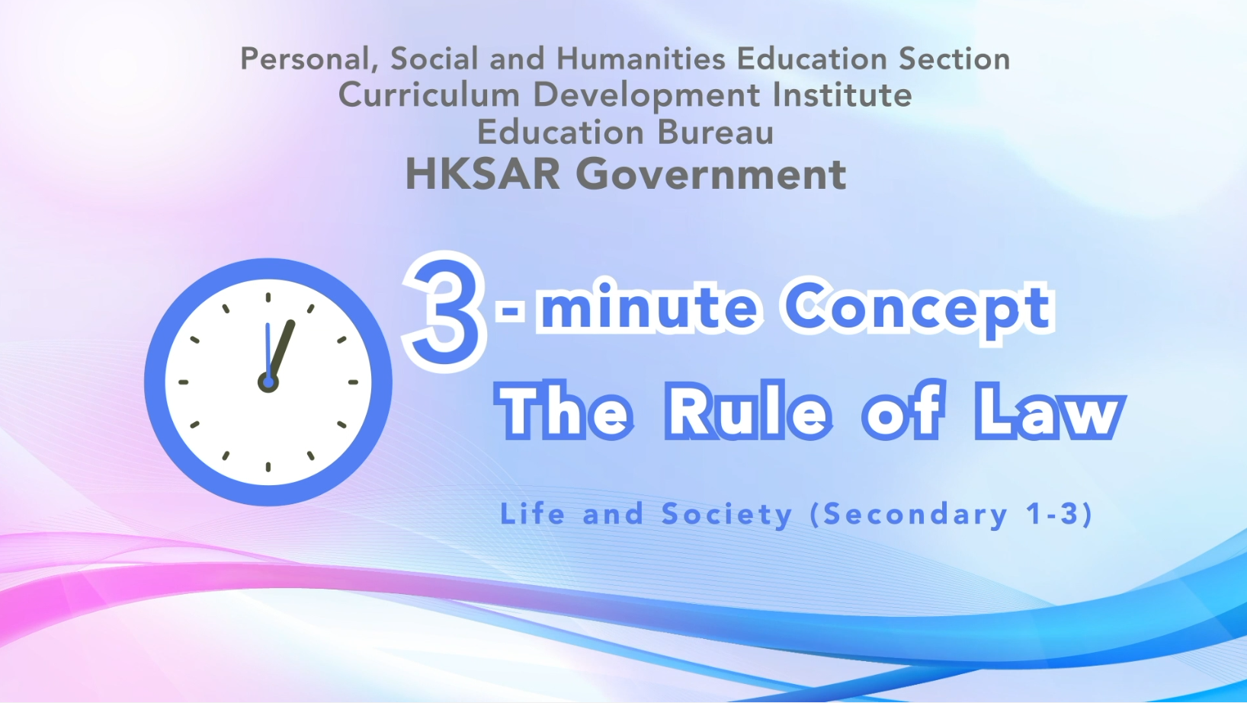
Citizenship, Economics and Society (Secondary 1-3)
Video link: https://emm.edcity.hk/media/Citizenship%2C+Economics+and+Society+%223-minute+Concept%22+Animated+Video+Clips+SeriesA+%2811%29+The+Rule+of+Law+%28English+subtitles+available%29/1_tnbnwhww
5. Teaching tips: Teachers must explain the following main points to students after playing the “Rule of Law” animated video clip:
1) Exercise of rights and freedoms carries with it responsibilities, and exercise of rights is not without boundary | Teachers must point out to students that the exercise of rights and freedoms carries with it responsibilities, and the exercise of rights is not without boundary; and one needs to respect the rights of others, consider the overall interests of society and abide by the law. For example, the exercise of rights may be subject to certain restrictions as provided by law when the restrictions are necessary for respect of the rights or reputations of others, or for the protection of national security or of public order, or of public health or morals. Teachers should further point out to students that any advocacy of unlawful acts is against the rule of law. Students should always be vigilant, not believe in remarks that advocate unlawful acts, and should always firmly uphold and protect the spirit of the rule of law. For the fundamental rights and duties of all Hong Kong residents, please refer to the following resource:  Basic Law Chapter III - Fundamental Rights and Duties of the Residents  https://www.basiclaw.gov.hk/en/basiclaw/chapter3.html
2) The Basic Law, which is the constitutional document of the HKSAR, ensures the principles of the rule of law | Teachers should point out to students that the Basic Law, which is the constitutional document of the HKSAR, ensures the principles of the rule of law (including equality before the law, all persons must abide by the law, the power of the government and all of its public servants is derived from law, and independent judicial power). For principles of the rule of law, please refer to the following resource:  Department of Justice - The rule of law  https://www.doj.gov.hk/en/our_legal_system/rule_of_law.html
3) Hong Kong has a solid rule of law foundation, which can ensure the continued prosperity and stability of the city | Teachers should point out to students that since its return to the motherland, Hong Kong has been making progress in international rankings on the rule of law. According to the Worldwide Governance Indicators project of the World Bank Group, Hong Kong’s percentile rank in respect to the rule of law was 69.85 in 1996. With the full implementation of “one country, two systems” and safeguards provided for by the Basic Law after return to the motherland, Hong Kong’s score reached 74.75 in 2000, and has been consistently above 90 since 2003 until now which demonstrates that the city’s rule of law has a solid foundation. Teachers can further point out to students that the “rule of law” is an important cornerstone for Hong Kong as a leading international financial and business centre. It provides legal protection and creates a fair business environment for Hong Kong people and commercial organisations, which is crucial to the continued prosperity and stability of Hong Kong. For the importance of “rule of law” to Hong Kong, please refer to the following resources:  Secretary of Justice speaks with teachers on rule of law at training course  https://www.info.gov.hk/gia/general/202206/01/P2022060100559.htm?fontSize=1  特首：說好香港真實法治故事  (Chinese version only)  https://www.news.gov.hk/chi/2022/11/20221111/20221111_103038_910.html

6. Consolidation questions : (See next page)

“3-minute Concept” Animated Video Clips Series:

“Rule of Law”

Worksheet

Watch the animated video clip “Rule of Law” and answer the following questions.

A. Fill-in-the-blank Questions
Put the correct answers in the spaces provided.
The following principles of the rule of law have been mentioned in the animated video clip:

B. True or False
Study the following sentences about the principles of the rule of law stipulated in the Basic Law. Put a “T” in the blank for correct description and an “F” for incorrect description.
 | The Basic Law stipulates that all Hong Kong residents shall be equal before the law. | T
 | The Basic Law stipulates that only permanent residents of the Hong Kong Special Administrative Region (HKSAR) shall have the obligation to abide by the laws in force in the HKSAR. | F

 | The Basic Law stipulates that the National People’s Congress authorizes the HKSAR to exercise a high degree of autonomy and enjoy executive, legislative and independent judicial power, including that of final adjudication, in accordance with the provisions of the Basic Law. | T

C. Short Question
How does the HKSAR ensure that judges shall exercise their judicial power independently?
The courts of the Hong Kong Special Administrative Region shall
exercise judicial power independently, free from any interference.
Members of the judiciary shall be immune from legal action in the
performance of their judicial functions.

The End

